"Gyroskopiya i Navigatsiya" №2, 2009
CONTENTS
O. Meister, N. Frietsch, Ch. Ascher, G. F. Trommer | Adaptive path planning for VTOL-UAVs | 3
This paper addresses the development of an adaptive path planning algorithm for a small vertical take-off and landing (VTOL) unmanned aerial vehicle (UAV) with a take off weight below 1 kg. The UAV was developed for versatile surveillance and reconnaissance applications in close-up range up to 10 km. The UAV platform with the onboard navigation system is described. Improvements of new adapted ranging sensors - mandatory for adaptive path planning algorithms - on the platform are discussed. The adaptive path planning algorithms including collision avoidance strategies of the platform are investigated. The development of a powerful simulation environment of the complete UAV including identified sensor characteristics which is essential for developing and testing of path planning algorithms is presented. The benefits of different planning algorithms are discussed and compared using a powerful simulation tool and validated by real test flight experiments.
B.G.Gursky, V.L.Solunin, A.I.Novikov | Navigation system of the unmanned ground-based vehicle | 12
The system solution is given for the problem of accuracy increase in the navigation integrated system of the ground-launched unmanned aerial vehicles, with due account of its application. Sequential performance is proposed for a series of interconnected tasks, namely: algorithm development for the odometric and satellite navigation system, generation of the autonomous local differential network, development of SINS prelaunch calibration algorithms, algorithm development for inertial satellite navigation system.
E.I.Veremei, M.V.Sotnikova | H∞-optimization procedure applied to synthesis of sea disturbance filters | 24
The paper is devoted to some advanced questions connected with analytical design problems for the marine vehicles stabilization systems. New spectral approach is considered to construct a stable digital filter included to the special multipurpose structure of stabilization system. A reduction of the rudders deflections, generated by the sea waves in the certain frequency band, is accepted as an initial requirement for the synthesis. At the same time it is taken into account that the closed system must be stable, nonstatic with respect to the regulated variables and its step response must be limited. It is shown that the mentioned problem can be posed in the framework of H∞-optimization theory. Nevertheless it is very difficult to use well known methods of this theory for a filter synthesis due to a presence of non-classical dynamical requirements and restrictions. To overcome the correspondent troubles new spectral method of a filter synthesis is proposed. This method allows to find an admissible filter with the help of Nevanlinna-Pick interpolation problem solution. Proposed approach is illustrated by the example of a digital filter synthesis for an autopilot that keeps a marine ship on a preset heading taking into account the sea wave disturbance.
N.V.Mikhailov, V.F.Mikhailov | Disambiguation method of GPS phase measurements applied to spacecraft autonomous relative navigation | 37
Phase ambiguity resolution method proposed by the authors earlier now is applied to solution of the determination problem of low earth-orbit satellite relative position by the data of navigation satellites. Results of the relative navigation method use with one fixed-frequency GPS receiver both for model data and experimental data, in particular, using GPS data recorded during project GRACE implementation, are discussed. Simulation results show satisfactory quality of relative coordinates estimate on the base up to 30 km.
V.V.Balashov, A.G.Bakhmurov, D.Yu.Volkanov, R.L.Smelyansky, M.V.Chistolinov, N.V.Yuschenko, G.T.Mamontov, P.V.Yukhta | Experience of software environment DIANA for simulation and designing of on-board computing systems | 48
The article deals with the simulation software environment for onboard computing systems "Diana". It allows for designing a distributed computing system with consideration of processes taking place in the exchange channels. In doing so, simulation of failures in the exchange channels with reproduction of their working-off procedures is possible. Simulation results obtained by this software environment are represented on the time diagram visualizer. Environment DIANA was adapted to peculiarities of design and debugging of marine computing systems assumed at CSRI Elektropribor. The environment received approval on the fragment of marine integrated navigation system model. The results of using the environment are given.
V.M.Shalaginov | Quaternion computing algorithms using known values of matrix of vehicle orientation | 56
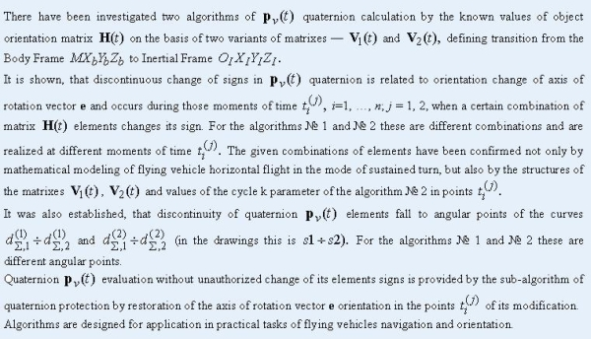
S.F.Konovalov, J.B.Seo | Reasons of magnetic flux uneven distribution in the space of Q-flex accelerometer force-balance transducers | 72
Accuracy characteristics and measurement range of Q-flex accelerometers are determined in a great deal by the state of the magnetic systems (assemblies) of their compensation torquers. It is known that despite using symmetric forms for magnetic conductor assemblies of plunger torquers in devices of Q-flex type, the magnetic flux density (B) is non-uniformly distributed along circumference of ring air gaps, and deviation of B value in separate samples of magnetic systems relative to average value of B exerts essential influence on characteristics of devices. The results of experiments allowing us to establish how the distribution instability of magnetic flux density B depend on properties of materials used in making the parts of the magnetic systems are described in the article, and also they allows us to reveal how the cyclic temperature changes and the magnetic systems long holding at high temperatures have influence on value of B. The reasons of occurrence of non-uniform distribution are defined in the article. The description of the special installation designed for testing the magnetic flux density distribution are given. The recommendation on obtaining the qualitative Q-flex accelerometer magnetic systems are given.
Materials of XI conference of young scientists Navigation and Motion Control
Paper abstracts | 80
International Public Association
The Academy of Navigation and Motion Control
O f f i c i a l i n f o r m a t i o n
President of the Academy of Navigation and Motion Control, Academician of the RAS, Vladimir Peshekhonov is 75 | 111

XXVII General meeting of the Academy of Navigation and Motion Control | 115

All-Russia workshop Up-to-date methods of navigation and motion control | 118
New books
Necessary and useful book | 121
Information
O.A.Stepanov  International Satellite navigation forum 2009 | 123

Russian and international conferences, symposiums, and exhibitions | 128

